Word Embeddings

Definition
# Source: AI Source: Provided by: [Data Path: Persons Table -> ID Column: 1, Name_En Column: Motasem Essam] -> From: [ChatGPT] on [12/10/2025]
Word Embeddings are a text encoding technique that represents words as dense, continuous vectors in a high-dimensional space. Unlike one-hot encoding or Bag of Words, embeddings capture semantic meaning and relationships between words.

Key Idea
# Source: AI Source: Provided by: [Data Path: Persons Table -> ID Column: 1, Name_En Column: Motasem Essam] -> From: [ChatGPT] on [12/10/2025]
Words with similar meanings are represented by vectors that are close together in the embedding space. For example, "king" and "queen" would have similar vectors, allowing models to capture context and word relationships.

How It Works
# Source: AI Source: Provided by: [Data Path: Persons Table -> ID Column: 1, Name_En Column: Motasem Essam] -> From: [ChatGPT] on [12/10/2025]
- Each word is mapped to a fixed-length vector of real numbers.
- The vectors are trained on large text corpora to capture semantic and syntactic relationships.
- Similar words or words used in similar contexts have similar vector representations.

Example
# Source: AI Source: Provided by: [Data Path: Persons Table -> ID Column: 1, Name_En Column: Motasem Essam] -> From: [ChatGPT] on [12/10/2025]
Original words: "king", "queen", "man", "woman"
Embedding vectors (simplified example):
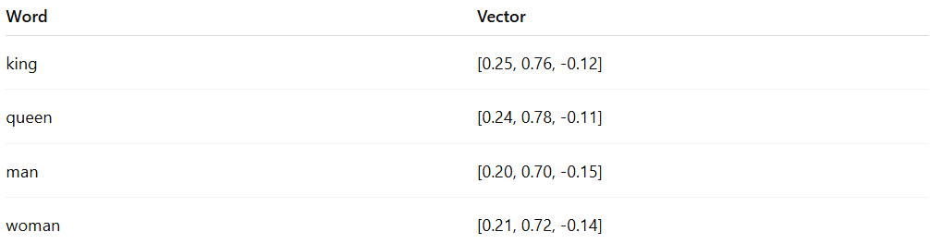
Word | Vector
king | [0.25, 0.76, -0.12]
queen | [0.24, 0.78, -0.11]
man | [0.20, 0.70, -0.15]
woman | [0.21, 0.72, -0.14]
- Semantic relationships can be computed using cosine similarity.
- Example: "king" - "man" + "woman" ≈ "queen"

Popular Word Embedding Methods
# Source: AI Source: Provided by: [Data Path: Persons Table -> ID Column: 1, Name_En Column: Motasem Essam] -> From: [ChatGPT] on [12/10/2025]
- Word2Vec – predicts a word based on its context (CBOW) or predicts context from a word (Skip-gram)
- GloVe – builds embeddings based on word co-occurrence statistics
- FastText – incorporates subword information for better handling of rare words
- Contextual embeddings (BERT, GPT) – embeddings depend on the word’s context in a sentence

Applications
# Source: AI Source: Provided by: [Data Path: Persons Table -> ID Column: 1, Name_En Column: Motasem Essam] -> From: [ChatGPT] on [12/10/2025]
- Text classification and sentiment analysis
- Named entity recognition (NER)
- Machine translation and text generation
- Semantic similarity and clustering

Advantages
# Source: AI Source: Provided by: [Data Path: Persons Table -> ID Column: 1, Name_En Column: Motasem Essam] -> From: [ChatGPT] on [12/10/2025]
- Captures semantic and syntactic meaning of words
- Reduces dimensionality compared to one-hot vectors
- Enables transfer learning with pretrained embeddings

Disadvantages
# Source: AI Source: Provided by: [Data Path: Persons Table -> ID Column: 1, Name_En Column: Motasem Essam] -> From: [ChatGPT] on [12/10/2025]
- Requires large datasets or pretrained embeddings for quality vectors
- Fixed embeddings (like Word2Vec) do not account for contextual variations
- Computationally more expensive than simple encodings

